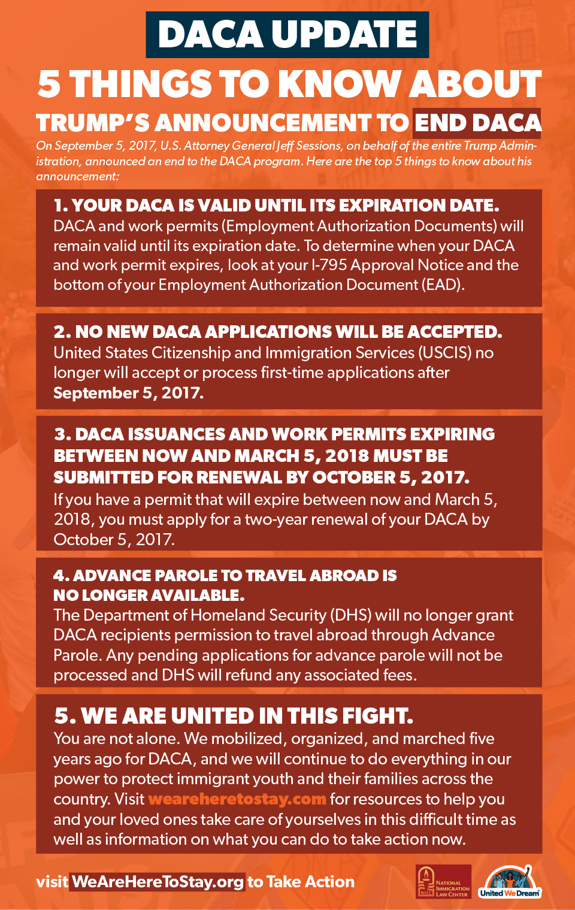

Additional Resources (provided by CA Dept. of Social Services):

Catholic Charities Diocese of Orange

1820 E. 16th St., Santa Ana, Ca 92701

(714) 347-9664

[www.ccoc.org](http://www.ccoc.org)

Public Law Center

601 W. Civic Center Drive, Santa Ana, Ca 92701

(213) 736-8136

[www.lls.edu/lijc](http://www.lls.edu/lijc)

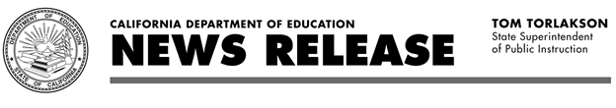

|  |  |
| --- | --- |
| REL#17-60 | CONTACT: Robert Oakes |
| FOR IMMEDIATE RELEASE | PHONE: 916-319-0818 |
| September 5, 2017 | E-MAIL: [communications@cde.ca.gov](mailto:communications@cde.ca.gov) |
|  |  |

**State Schools Chief Tom Torlakson Denounces End of Federal Dream Act, Tells California Students State Protection Remains**

SACRAMENTO— State Superintendent of Public Instruction Tom Torlakson today denounced President Trump’s decision to suspend the federal Dream Act and told California public school students and their families that California will keep protecting and supporting them.

“Our country made an honest deal with these students—study hard, earn your degree, and you will get a fair chance to compete for college. We should keep deals, not break them. We should support dreams, not defer and destroy them,” Torlakson said. “These students embody the American dream. Their hard work, energy, dedication, and diverse background help them contribute to our economy, while adding to the rich cultural heritage that makes California a dynamic global leader.”

Torlakson called on Congress to act swiftly to restore the program. “I urge Congress to step up, find a permanent path to citizenship, and protect these immigrants,” he said.

Trump suspended the 2012 federal Deferred Action for Childhood Arrivals (DACA) program, which enables “Dreamers”—young undocumented immigrants who were brought to the country as children—to live, study, and work in the U.S. More than 200,000 of these students live in California. He gave Congress six months to find a legislative solution.

Torlakson called the decision by Trump a “mean-spirited, political attack on students who are working hard to succeed.”

“I want to let all those students know that the American Dream remains safe and secure in California,” he said. “Our great state will continue supporting these terrific students and their families.”

The state has its own California Dream Act, which is unrelated to DACA and allows undocumented students to receive state financial aid for college. The California Student Aid Commission (CSAC) operates this program and previously reminded students that the Commission will take all available legal precautions to protect California Dream Act information, which is used solely to determine eligibility for state financial aid and is not shared with any other government agency.

Torlakson earlier in 2017 sent a letter to public school officials statewide and asked them to remind students and parents to file applications for financial aid. The [letter](http://www.cde.ca.gov/nr/el/le/yr17ltr0221.asp) is posted on the CDE Web site.

# # # #

The California Department of Education is a state agency led by State Superintendent of Public Instruction Tom Torlakson. For more information, please visit the [California Department of Education](http://www.cde.ca.gov/)’s Web site or by [mobile device](http://m.cde.ca.gov/). You may also follow Superintendent Torlakson on [Twitter](https://twitter.com/cadepted), [Facebook](http://www.facebook.com/CAEducation), and [YouTube](http://www.youtube.com/caeducation).